PERANCANGAN PROTOTIPE SISTEM PENDUKUNG KEPUTUSAN ALA-ALA
TUGAS SARJANA
Diajukan untuk memperoleh gelar Sarjana Teknik dari Program Studi Teknik Industri Institut Teknologi Bandung

Disusun oleh
KREITON SITORUS
13416006

PROGRAM STUDI TEKNIK INDUSTRI
INSTITUT TEKNOLOGI BANDUNG
2022
(halaman ini sengaja dikosongkan)

Lembar Pengesahan
He heard quiet steps behind him. That didn't bode well. Who could be following him this late at night and in this deadbeat part of town? And at this particular moment, just after he pulled off the big time and was making off with the greenbacks. Was there another crook who'd had the same idea, and was now watching him and waiting for a chance to grab the fruit of his labor? Or did the steps behind him mean that one of many law officers in town was on to him and just waiting to pounce and snap those cuffs on his wrists? He nervously looked all around. Suddenly he saw the alley. Like lightning he darted off to the left and disappeared between the two warehouses almost falling over the trash can lying in the middle of the sidewalk. He tried to nervously tap his way along in the inky darkness and suddenly stiffened: it was a dead-end, he would have to go back the way he had come. The steps got louder and louder, he saw the black outline of a figure coming around the corner. Is this the end of the line? he thought pressing himself back against the wall trying to make himself invisible in the dark, was all that planning and energy wasted? He was dripping with sweat now, cold and wet, he could smell the fear coming off his clothes. Suddenly next to him, with a barely noticeable squeak, a door swung quietly to and fro in the night's breeze. Could this be the haven he'd prayed for? Slowly he slid toward the door, pressing himself more and more into the wall, into the dark, away from his enemy. Would this door save his hide?

Surat Pernyataan
He heard quiet steps behind him. That didn't bode well. Who could be following him this late at night and in this deadbeat part of town? And at this particular moment, just after he pulled off the big time and was making off with the greenbacks. Was there another crook who'd had the same idea, and was now watching him and waiting for a chance to grab the fruit of his labor? Or did the steps behind him mean that one of many law officers in town was on to him and just waiting to pounce and snap those cuffs on his wrists? He nervously looked all around. Suddenly he saw the alley. Like lightning he darted off to the left and disappeared between the two warehouses almost falling over the trash can lying in the middle of the sidewalk. He tried to nervously tap his way along in the inky darkness and suddenly stiffened: it was a dead-end, he would have to go back the way he had come. The steps got louder and louder, he saw the black outline of a figure coming around the corner. Is this the end of the line? he thought pressing himself back against the wall trying to make himself invisible in the dark, was all that planning and energy wasted? He was dripping with sweat now, cold and wet, he could smell the fear coming off his clothes. Suddenly next to him, with a barely noticeable squeak, a door swung quietly to and fro in the night's breeze. Could this be the haven he'd prayed for? Slowly he slid toward the door, pressing himself more and more into the wall, into the dark, away from his enemy. Would this door save his hide?

Panduan Penggunaan Hak Cipta
He heard quiet steps behind him. That didn't bode well. Who could be following him this late at night and in this deadbeat part of town? And at this particular moment, just after he pulled off the big time and was making off with the greenbacks. Was there another crook who'd had the same idea, and was now watching him and waiting for a chance to grab the fruit of his labor? Or did the steps behind him mean that one of many law officers in town was on to him and just waiting to pounce and snap those cuffs on his wrists? He nervously looked all around. Suddenly he saw the alley. Like lightning he darted off to the left and disappeared between the two warehouses almost falling over the trash can lying in the middle of the sidewalk. He tried to nervously tap his way along in the inky darkness and suddenly stiffened: it was a dead-end, he would have to go back the way he had come. The steps got louder and louder, he saw the black outline of a figure coming around the corner. Is this the end of the line? he thought pressing himself back against the wall trying to make himself invisible in the dark, was all that planning and energy wasted? He was dripping with sweat now, cold and wet, he could smell the fear coming off his clothes. Suddenly next to him, with a barely noticeable squeak, a door swung quietly to and fro in the night's breeze. Could this be the haven he'd prayed for? Slowly he slid toward the door, pressing himself more and more into the wall, into the dark, away from his enemy. Would this door save his hide?

Kata Pengantar
Lorem ipsum dolor sit amet, consectetur adipiscing elit. Vestibulum consequat mi quis pretium semper. Proin luctus orci ac neque venenatis, quis commodo dolor posuere. Curabitur dignissim sapien quis cursus egestas. Donec blandit auctor arcu, nec pellentesque eros molestie eget. In consectetur aliquam hendrerit. Sed cursus mauris vitae ligula pellentesque, non pellentesque urna aliquet. Fusce placerat mauris enim, nec rutrum purus semper vel. Praesent tincidunt neque eu pellentesque pharetra. Fusce pellentesque est orci.
Integer sodales tincidunt tristique. Sed a metus posuere, adipiscing nunc et, viverra odio. Donec auctor molestie sem, sit amet tristique lectus hendrerit sed. Cras sodales nisl sed orci mattis iaculis. Nunc eget dolor accumsan, pharetra risus a, vestibulum mauris. Nunc vulputate lobortis mollis. Vivamus nec tellus faucibus, tempor magna nec, facilisis felis. Donec commodo enim a vehicula pellentesque. Nullam vehicula vestibulum est vel ultricies.
Aliquam velit massa, laoreet vel leo nec, volutpat facilisis eros. Donec consequat arcu ut diam tempor luctus. Cum sociis natoque penatibus et magnis dis parturient montes, nascetur ridiculus mus. Praesent vitae lacus vel leo sodales pharetra a a nibh. Vestibulum ante ipsum primis in faucibus orci luctus et ultrices posuere cubilia Curae; Nam luctus tempus nibh, fringilla dictum augue consectetur eget. Curabitur at ante sit amet tortor pharetra molestie eu nec ante. Mauris tincidunt, nibh eu sollicitudin molestie, dolor sapien congue tortor, a pulvinar sapien turpis sed ante. Donec nec est elementum, euismod nulla in, mollis nunc.
halaman dikosongkan

Abstrak
He heard quiet steps behind him. That didn't bode well. Who could be following him this late at night and in this deadbeat part of town? And at this particular moment, just after he pulled off the big time and was making off with the greenbacks. Was there another crook who'd had the same idea, and was now watching him and waiting for a chance to grab the fruit of his labor? Or did the steps behind him mean that one of many law officers in town was on to him and just waiting to pounce and snap those cuffs on his wrists? He nervously looked all around. Suddenly he saw the alley. Like lightning he darted off to the left and disappeared between the two warehouses almost falling over the trash can lying in the middle of the sidewalk. He tried to nervously tap his way along in the inky darkness and suddenly stiffened: it was a dead-end, he would have to go back the way he had come. The steps got louder and louder, he saw the black outline of a figure coming around the corner. Is this the end of the line? he thought pressing himself back against the wall trying to make himself invisible in the dark, was all that planning and energy wasted? He was dripping with sweat now, cold and wet, he could smell the fear coming off his clothes. Suddenly next to him, with a barely noticeable squeak, a door swung quietly to and fro in the night's breeze. Could this be the haven he'd prayed for? Slowly he slid toward the door, pressing himself more and more into the wall, into the dark, away from his enemy. Would this door save his hide?
halaman dikosongkan

Abstract
He heard quiet steps behind him. That didn't bode well. Who could be following him this late at night and in this deadbeat part of town? And at this particular moment, just after he pulled off the big time and was making off with the greenbacks. Was there another crook who'd had the same idea, and was now watching him and waiting for a chance to grab the fruit of his labor? Or did the steps behind him mean that one of many law officers in town was on to him and just waiting to pounce and snap those cuffs on his wrists? He nervously looked all around. Suddenly he saw the alley. Like lightning he darted off to the left and disappeared between the two warehouses almost falling over the trash can lying in the middle of the sidewalk. He tried to nervously tap his way along in the inky darkness and suddenly stiffened: it was a dead-end, he would have to go back the way he had come. The steps got louder and louder, he saw the black outline of a figure coming around the corner. Is this the end of the line? he thought pressing himself back against the wall trying to make himself invisible in the dark, was all that planning and energy wasted? He was dripping with sweat now, cold and wet, he could smell the fear coming off his clothes. Suddenly next to him, with a barely noticeable squeak, a door swung quietly to and fro in the night's breeze. Could this be the haven he'd prayed for? Slowly he slid toward the door, pressing himself more and more into the wall, into the dark, away from his enemy. Would this door save his hide?
halaman dikosongkan

Daftar Isi
Lembar Pengesahan i
Surat Pernyataan ii
Panduan Penggunaan Hak Cipta iii
Kata Pengantar iv
Abstrak vi
Abstract viii
BAB 1 Pendahuluan 1
1.1 Latar Belakang 1
1.2 Rumusan Masalah 1
1.3 Tujuan dan Manfaat 1
1.4 Batasan dan Asumsi 2
1.5 Sistematika Penulisan 2
BAB 2 Kerangka Teori 3
2.1 Manajemen Logistik 3
2.1.1 Ruang Lingkup Logistik 3
2.1.2 Aktivitas Logistik 3
2.1.3 Ukuran Performa Logistik 3
2.2 Pemodelan Sistem 4
2.2.1 Situasi Masalah 4
2.2.2 Elemen Permasalahan 4
BAB 3 Metodologi 5
3.1 Pendekatan Penelitian 5
3.2 Tahapan Penelitian 5
3.2.1 Pemahaman Masalah 5
3.2.2 Formulasi Model 5
3.2.3 Pengembangan Prosedur Pencarian Solusi 6
3.2.4 Pengujian, Analisis, dan Perbaikan Model 6
3.2.5 Implementasi Keputusan 6
3.2.6 Pengumpulan Data 7

daftar gambar
daftar tabel
- Pendahuluan
He heard quiet steps behind him. That didn't bode well. Who could be following him this late at night and in this deadbeat part of town? And at this particular moment, just after he pulled off the big time and was making off with the greenbacks.

Latar Belakang
He heard quiet steps behind him. That didn't bode well. Who could be following him this late at night and in this deadbeat part of town? And at this particular moment, just after he pulled off the big time and was making off with the greenbacks.

Rumusan Masalah
Was there another crook who'd had the same idea, and was now watching him and waiting for a chance to grab the fruit of his labor? Or did the steps behind him mean that one of many law officers in town was on to him and just waiting to pounce and snap those cuffs on his wrists? He nervously looked all around. Suddenly he saw the alley.

Tujuan dan Manfaat
Like lightning he darted off to the left and disappeared between the two warehouses almost falling over the trash can lying in the middle of the sidewalk. He tried to nervously tap his way along in the inky darkness and suddenly stiffened: it was a dead-end, he would have to go back the way he had come. The steps got louder and louder, he saw the black outline of a figure coming around the corner. Is this the end of the line? he thought pressing himself back against the wall trying to make himself invisible in the dark, was all that planning and energy wasted?

Batasan dan Asumsi
He was dripping with sweat now, cold and wet, he could smell the fear coming off his clothes. Suddenly next to him, with a barely noticeable squeak, a door swung quietly to and fro in the night's breeze. Could this be the haven he'd prayed for? Slowly he slid toward the door, pressing himself more and more into the wall, into the dark, away from his enemy. Would this door save his hide?

Sistematika Penulisan
He heard quiet steps behind him. That didn't bode well. Who could be following him this late at night and in this deadbeat part of town? And at this particular moment, just after he pulled off the big time and was making off with the greenbacks.
- Kerangka Teori
He heard quiet steps behind him. That didn't bode well. Who could be following him this late at night and in this deadbeat part of town? And at this particular moment, just after he pulled off the big time and was making off with the greenbacks.

Manajemen Logistik
Was there another crook who'd had the same idea, and was now watching him and waiting for a chance to grab the fruit of his labor? Or did the steps behind him mean that one of many law officers in town was on to him and just waiting to pounce and snap those cuffs on his wrists?

Ruang Lingkup Logistik
He nervously looked all around. Suddenly he saw the alley. Like lightning he darted off to the left and disappeared between the two warehouses almost falling over the trash can lying in the middle of the sidewalk.

Aktivitas Logistik
He tried to nervously tap his way along in the inky darkness and suddenly stiffened: it was a dead-end, he would have to go back the way he had come. The steps got louder and louder, he saw the black outline of a figure coming around the corner. Is this the end of the line? he thought pressing himself back against the wall trying to make himself invisible in the dark, was all that planning and energy wasted?

Ukuran Performa Logistik
He was dripping with sweat now, cold and wet, he could smell the fear coming off his clothes. Suddenly next to him, with a barely noticeable squeak, a door swung quietly to and fro in the night's breeze. Could this be the haven he'd prayed for? Slowly he slid toward the door, pressing himself more and more into the wall, into the dark, away from his enemy. Would this door save his hide?

Pemodelan Sistem
He heard quiet steps behind him. That didn't bode well. Who could be following him this late at night and in this deadbeat part of town? And at this particular moment, just after he pulled off the big time and was making off with the greenbacks.

Situasi Masalah
Was there another crook who'd had the same idea, and was now watching him and waiting for a chance to grab the fruit of his labor? Or did the steps behind him mean that one of many law officers in town was on to him and just waiting to pounce and snap those cuffs on his wrists? He nervously looked all around. Suddenly he saw the alley. Like lightning he darted off to the left and disappeared between the two warehouses almost falling over the trash can lying in the middle of the sidewalk.

Elemen Permasalahan
He tried to nervously tap his way along in the inky darkness and suddenly stiffened: it was a dead-end, he would have to go back the way he had come. The steps got louder and louder, he saw the black outline of a figure coming around the corner. Is this the end of the line? he thought pressing himself back against the wall trying to make himself invisible in the dark, was all that planning and energy wasted? He was dripping with sweat now, cold and wet, he could smell the fear coming off his clothes. Suddenly next to him, with a barely noticeable squeak, a door swung quietly to and fro in the night's breeze. Could this be the haven he'd prayed for? Slowly he slid toward the door, pressing himself more and more into the wall, into the dark, away from his enemy. Would this door save his hide?
- Metodologi

Pendekatan Penelitian
Dalam penelitian ini, p
- Pengujian, analisis, dan perbaikan model
- Implementasi keputusan
Pembagian ini digunakan karena memberikan poin tersendiri pada pengembangan prosedur pencarian solusi atau algoritma. Hal ini menjadi penting karena tahap ini

Tahapan Penelitian
Pada bagian ini akan dijelaskan bagaimana tahapan-tahapan metodologi penelitian operasional diterapkan pada penelitian ini. adfsadf

`Gambar xx`

Pemahaman Masalah
Sudah diketahui bahwa permasalahan yang dihadapi merupakan permasalahan logistik.

Formulasi Model
Berbekalkan pemahaman yang terstruktur akan permasalahan, dalam tahap ini, Penyusunan model merupakan kombinasi dari penggunaan konsep-konsep yang sudah ada (pendekatan struktural) dengan kreativitas analis untuk merunut sendiri permasalahan yang diteliti (pendekatan proses). Penelitian operasional sebagai sebuah disiplin memiliki arsenal yang besar untuk pengembangan model, seperti: pemrograman linear, pemrograman integer, pemrograman dinamis, dan simulasi. Dalam penelitian ini, setiap model yang dicoba akan melalui langkah verifikasi. Model dipastikan memiliki logika yang koheren yang sesuai dengan intensi pembuatan model. Verifikasi yang dilakukan di penelitian pada tahap ini adalah merunut kembali transformasi satuan-satuan yang ada dalam model. Karena sifatnya yang iteratif, model yang digunakan dalam penelitian dan dijabarkan pada [[bab 4]] (4.2) hanya versi termutakhir.

Pengembangan Prosedur Pencarian Solusi
Sebuah model datang satu paket dengan pencari solusinya. Prosedur sistematis manipulasi model untuk mencari solusi ini biasa disebut dengan algoritma. Tahapan ini berfokus pada desain algoritma tersebut dan seluruh hasil termutakhir, yang akhirnya digunakan dalam penelitian, disajikan pada [[bab 4]] (4.3).

Pengujian, Analisis, dan Perbaikan Model
Solusi dari permasalahan operasionalisasi distribusi ini merupakan bagian dari sebuah rangkaian aktivitas yang lebih besar seperti yang diimplikasikan pada [[bab 1]] (1.2) dalam Gambar xx. Karena komponennya yang banyak dan saling memengaruhi secara nonlinear serta keberadaan ketakpastian dalam sistem, metode terbaik untuk menguji performa model yang sudah dikembangkan adalah simulasi [@ravindran2009]. Melalui metode ini, dapat dilakukan eksperimen terhadap input sistem dan parameter model perencanaan. Pada persamaan 3.3.

Implementasi Keputusan
Ketika sebuah model dinyatakan valid dan sudah diuji sedemikian rupa terhadap perubahan-perubahan, solusi dapat diajukan untuk diimplementasikan kembali ke sistem nyata. Untuk dapat diimplementasi dengan baik, perlu dilakukan analisis implikasi manajerial untuk memeriksa perubahan-perubahan yang diperlukan seiring dengan implementasi penggunaan model dalam rangkaian aktivitas sistem. Hasil dan pembahasan analisis ini akan dijabarkan pada [[bab 4]] (4.5). Selain itu, akan diperlukan perencanaan *budget* dan *timeline* implementasi sebagai sebuah proyek, namun hal tersebut tidak masuk dalam lingkup penelitian.

Pengumpulan Data
Pengumpulan data dan pengolahan -- data merupakan sebuah komponen dalam pendekatan penelitian operasional yang sifatnya paralel dengan seluruh tahap. Setiap tahapan bisa jadi membutuhkan data yang berbeda dan proses pengolahan yang berbeda. Seluruh kegiatan pengumpulan data akan dirangkum pada [[bab 4]] (4.6).
(3.1)
(3.2)
(3.3)
(3.4)
(3.5)
(3.6)

(Equation 3.7)
(Equation 3.8)

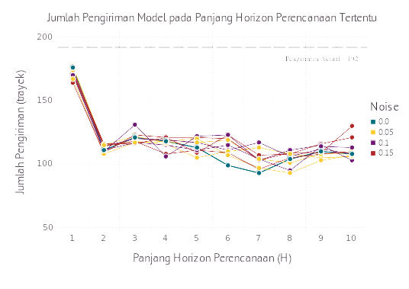
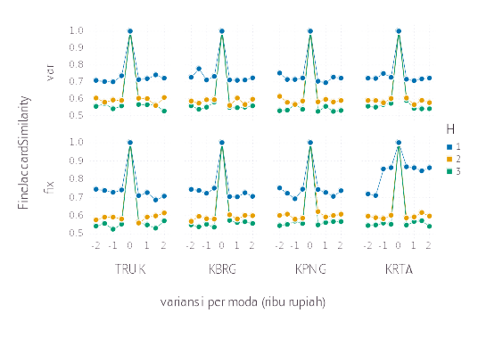

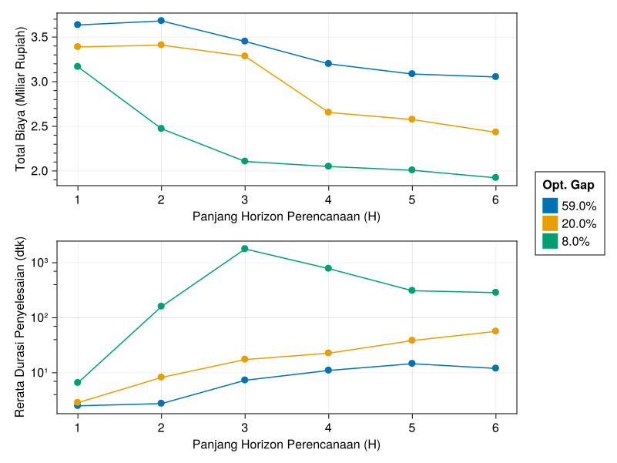

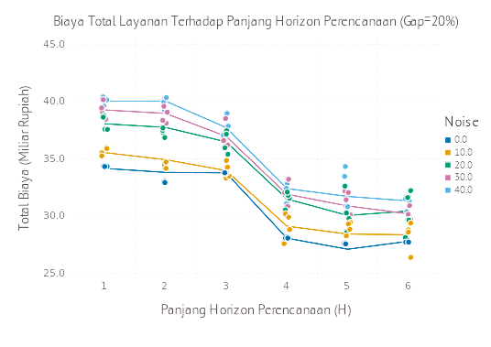
asdfasdfsadfasdfasdfasdfsadfasdfsadfasdfsadfsadfsadfasdfsadfasdfsadfasdfasdfasdfasdfsadfasdfasdfsadfsadfasdfaa He heard quiet steps behind him. That didn't bode well. Who could be following him this late at night and in this deadbeat part of town? And at this particular moment, just after he pulled off the big time and was making off with the greenbacks. Was there another crook who'd had the same idea, and was now watching him and waiting for a chance to grab the fruit of his labor?
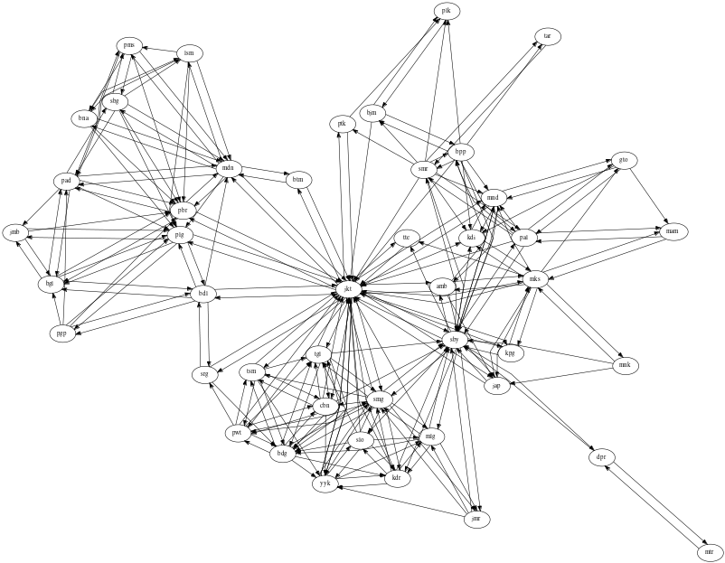
Or did the steps behind him mean that one of many law officers in town was on to him and just waiting to pounce and snap those cuffs on his wrists? He nervously looked all around. Suddenly he saw the alley. Like lightning he darted off to the left and disappeared between the two warehouses almost falling over the trash can lying in the middle of the sidewalk. He tried to nervously tap his way along in the inky darkness and suddenly stiffened: it was a dead-end, he would have to go back the way he had come. The steps got louder and louder, he saw the black outline of a figure coming around the corner.

Is this the end of the line? he thought pressing himself back against the wall trying to make himself invisible in the dark, was all that planning and energy wasted? He was dripping with sweat now, cold and wet, he could smell the fear coming off his clothes. Suddenly next to him, with a barely noticeable squeak, a door swung quietly to and fro in the night's breeze. Could this be the haven he'd prayed for?
